**LAB 12**

**12.1 Write a program in C++ to find the maximum number between two numbers using a pointer**

**SOURCE CODE**

**#include <iostream>**

**using namespace std;**

**int main()**

**{**

**int fno,sno,*ptr1=&fno,*ptr2=&sno;**

**cout<<"Input the first number : ";**

**cin>>fno;**

**cout<<"Input the second number : ";**

**cin>>sno;**

**if(*ptr1>*ptr2)**

**{**

**cout<<"The maximum number is: "<<*ptr1<<endl;**

**}**

**else**

**{**

**cout<<"The maximum number is: "<<*ptr2<<endl;**

**}**

**}**

**OUTPUT**

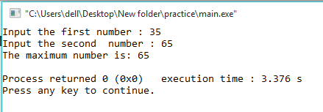

**11.2 Write an any example in C++ of passing Pointers to functions**

**SOURCE CODE**

**#include <iostream>**

**using namespace std;**

**int funtionthatcallsapointer(int *a, int *b, int *c)**

**{**

**\*c = *a + *b;**

**}**

**int main()**

**{**

**int a,b,c=0;**

**cout<<"Enter a first number: "<<endl;**

**cin>>a;**

**cout<<"Enter a second number: "<<endl;**

**cin>>b;**

**funtionthatcallsapointer(&a, &b, &c);**

**cout<<"The sum of the input is: "<<c;**

**}**

**OUTPUT**

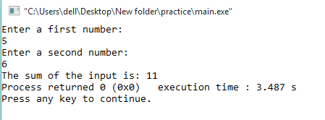

**12.3 Write a program in C++ to show the basic declaration of pointer.**

**SOURCE CODE**

**#include <iostream>**

**using namespace std;**

**int main()**

**{**

**int m=10, n, o;**

**int *z = &m ;**

**cout<<"-------------------------------------------------------\n"<<endl;**

**cout<<" Here is m=10, n and o are two integer variable and *z is an integer"<<endl;**

**cout<<"\n\n z stores the address of m = "<<z<<endl;**

**cout<<"\n *z stores the value of m = "<<*z<<endl;**

**cout<<"\n &m is the address of m = "<<&m<<endl;**

**cout<<"\n &n stores the address of n = "<<&n<<endl;**

**cout<<"\n &o stores the address of o = "<<&o<<endl;**

**cout<<"\n &z stores the address of z = "<<&z<<endl;**

**}**

**OUTPUT**

